 | 13.1.6 Editors - Shader Editor - Header - Add Menu - Input
Table of content
Detailed table of content 1
Add menu - Input 5
Ambient Occlusion 5
Attribute 6
Bevel 7
Camera Data 7
Fresnel 8
Geometry 8
Hair Info 9
Layer Weight 10
Light Path 10
Object Info 11
Particle Info 12
Point Info 13
RGB 13
Tangent 14
Texture Coordinate 14
UV Along Stroke 15
UV Map 15
Value 16
Vertex Color 16
Volume Info 17
Wireframe 17

Detailed table of content

Detailed table of content
Detailed table of content 1
Add menu - Input 5
Ambient Occlusion 5
Inputs 5
Color 5
Distance Cycles Only 5
Normal 5
Properties 5
Samples Cycles Only 5
Inside Cycles Only 5
Only Local Cycles Only 6
Outputs 6
Color 6
AO 6
Attribute 6
Properties 6
Name 6
Outputs 6
Color 6
Vector 6
Factor 7
Bevel 7
Inputs 7
Radius 7
Normal 7
Properties 7
Samples 7
Outputs 7
Normal 7
Camera Data 7
Inputs 7
Properties 7
Outputs 8
View Vector 8
View Z Depth 8
View Distance 8
Fresnel 8
Inputs 8
IOR 8
Normal 8
Outputs 8
Factor 8
Geometry 8
Outputs 8
Position 8
Normal 9
Tangent 9
True Normal 9
Incoming 9
Parametric 9
Backfacing 9
Pointiness Cycles Only 9
Random Per Island Cycles Only 9
Hair Info 9
Outputs 9
Is Strand 9
Intercept 9
Thickness 9
Tangent Normal 10
Random 10
Layer Weight 10
Inputs 10
Blend 10
Normal 10
Outputs 10
Fresnel 10
Facing 10
Light Path 10
Outputs 10
Is Camera Ray 10
Is Shadow Ray 10
Is Diffuse Ray 11
Is Glossy Ray 11
Is Singular Ray Cycles Only 11
Is Reflection Ray Cycles Only 11
Is Transmission Ray Cycles Only 11
Ray Length Cycles Only 11
Ray Depth 11
Diffuse Depth Cycles Only 11
Glossy Depth Cycles Only 11
Transparent Depth Cycles Only 11
Transmission Depth Cycles Only 11
Object Info 11
Outputs 12
Location 12
Color 12
Alpha 12
Object Index 12
Material Index 12
Random 12
Particle Info 12
Outputs 12
Index 12
Random 12
Age 12
Lifetime 12
Location 13
Size 13
Velocity 13
Angular Velocity 13
Point Info 13
Outputs 13
Position 13
Radius 13
Random 13
RGB 13
Properties 13
Outputs 13
Color / RGBA 13
Tangent 14
Properties 14
Direction Type 14
Outputs 14
Tangent 14
Texture Coordinate 14
Properties 14
Object 14
From Instancer 14
Output 14
Generated 14
Normal 14
UV 14
Object 14
Camera 15
Window 15
Reflection 15
UV Along Stroke 15
Properties 15
Use Tips 15
Outputs 15
UV 15
UV Map 15
Properties 16
From Instancer Cycles Only 16
UV Map edit box 16
Outputs 16
UV 16
Value 16
Properties 16
Default Value 16
Outputs 16
Value 16
Vertex Color 16
Properties 16
Vertex Color 16
Outputs 17
Color 17
Alpha 17
Volume Info 17
Outputs 17
Color 17
Density 17
Flame 17
Temperature 17
Wireframe 17
Inputs 17
Size 17
Properties 18
Pixel Size 18
Outputs 18
Factor 18

Add menu - Input

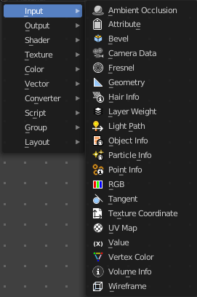
The Input menu contains Input node types.

The content is the same for all three sub modes. Note that you need to tick Use Nodes to activate the menu items when you are in Line Style sub mode.

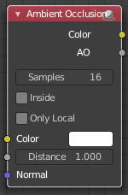
Ambient Occlusion
Ambient Occlusion is a technique to self shadow the geometry of objects. Corners are usually darker than flat areas.
Hint, you should either use Ambient Occlusion or Global Illumination, since GI includes AO techniques.

Inputs

Color
Tint for AO output color.

Distance Cycles Only
Distance up to which other objects are considered to occlude the shading point.

Normal
Normal used for ambient occlusion. If nothing is connected the default shading normal is used.

Properties

Samples Cycles Only
Number of samples to use for ray traced ambient occlusion sampling. Keep as low as possible for an optimal performance.

Inside Cycles Only
Detect convex rather than concave shapes, by computing occlusion inside mesh.

Only Local Cycles Only
Only detect occlusion from the object itself, and not others.

Outputs

Color
Ambient occlusion with color tint.

AO
Ambient occlusion factor without color tint.

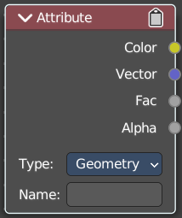
Attribute
The Attribute node allows you to retrieve attributes attached to an object or mesh.

Properties

Name
Name of the attribute that you want to use.
Most attributes are easily available. Some not. Examples of not so obvious ones:
Vertex Color Layers can be retrieved this by their names.
Density gives a scalar defining the density of any smoke inside the Fluid Domain.
Color gives the color of the smoke inside the Fluid Domain. The color and vector outputs are the same. The Factor output is an average of the channels.
Temperature gives a scalar defining the temperature of the volume. Values in the range 0 - 1 map to 0 - 1000 kelvin. This may be used to render physically-based fire with the Blackbody or Principled Volume shaders. All three outputs are the same.
Flame gives a scalar defining the density of any fire inside the Fluid Domain. All three outputs are the same.
Ocean Foam gives a scalar defining where foam might appear when using an Ocean Modifier. This depends on the name you give this property.

Outputs

Color
RGB color interpolated from the attribute.

Vector
XYZ vector interpolated from the attribute.

Factor
Scalar value interpolated from the attribute.

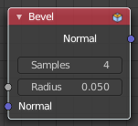
Bevel
Cycles Only
The Bevel shader node can be used for rendering rounded corners to capture specular highlights. The geometry is not modified. The modification happens at shader level.

Inputs

Radius
Width of the bevel effect on edges.

Normal
Normal to apply bevel on top of, to be combined with a Bump node for example.

Properties

Samples
Number of samples to take for each shader evaluation. More samples give more accurate results, but are also slower to render. The default value of 4 works well for most cases, with any noise resolved by using more AA samples.

Outputs

Normal
Standard normal output.

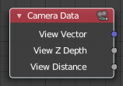
Camera Data
With the Camera Data node you can get get information about the position of the object relative to the camera. This could be used for example to change the shading of objects further away from the camera, or make custom fog effects.

Inputs
This node has no inputs.

Properties
This node has no properties.

Outputs

View Vector
A camera space vector from the camera to the shading point.

View Z Depth
The distance each pixel is away from the camera.

View Distance
Distance from the camera to the shading point.

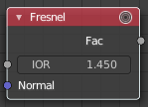
Fresnel
The Fresnel effect says that the more a face goes towards 180 degrees, the more it is reflecting. With 180 degrees every object in real life is 100% reflective, no matter how the material is.

Inputs

IOR
Index of refraction (IOR) of the material being entered.

Normal
Input meant for plugging in bump or normal maps which will affect the output.

Outputs

Factor
Fresnel weight, indicating the probability with which light will reflect off the layer rather than passing through.

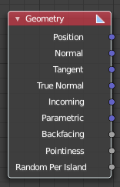
Geometry
The Geometry node gives geometric information about the current shading point. All vector coordinates are in World Space. For volume shaders, only the position and incoming vector are available.

Outputs

Position
Position of the shading point.

Normal
Shading normal at the surface (includes smooth normals and bump mapping).

Tangent
Tangent at the surface.

True Normal
Geometry or flat normal of the surface.

Incoming
Vector pointing towards the point the shading point is being viewed from.

Parametric
Parametric coordinates of the shading point on the surface. To area lights it outputs its UV coordinates in planar mapping and in spherical coordinates to point lights.

Backfacing
1.0 if the face is being viewed from the back side, 0.0 for the front side.

Pointiness Cycles Only
An approximation of the curvature of the mesh per vertex. Lighter values indicate convex angles, darker values indicate concave angles. It allows you to do effects like dirt maps and wear-off effects.

Random Per Island Cycles Only
A random value for each connected component (island) of the mesh. It is useful to add variations to meshes composed of separated units like tree leaves, wood planks, or curves of multiple splines.

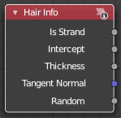
Hair Info
The Hair Info node gives access to Hair information.

Outputs

Is Strand
Returns 1 when the shader is acting on a strand, otherwise 0.

Intercept
The point along the strand where the ray hits the strand (1 at the tip and 0 at the root).

Thickness
The thickness of the strand at the point where the ray hits the strand.

Tangent Normal
Tangent normal of the strand.

Random
A random per-hair value in the range from 0 to 1. It can for example be used in combination with a color ramp, to randomize the hair color.

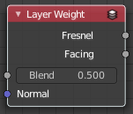
Layer Weight
The Layer Weight node outputs a weight typically used for layering shaders with the Mix Shader node.

Inputs

Blend
Bias the output towards all 0 or all 1. Useful for uneven mixing of shaders.

Normal
Input meant for plugging in bump or normal maps which will affect the output.

Outputs

Fresnel
Dielectric Fresnel weight, useful for example for layering diffuse and glossy shaders to create a plastic material. This is like the Fresnel node, except that the input of this node is in the often more convenient 0.0 to 1.0 range.

Facing
Weight that blends from the first to the second shader as the surface goes from facing the viewer to viewing it at a grazing angle.

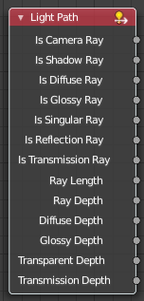
Light Path
The Light Path node is used to find out for which kind of incoming ray the shader is being executed. This is useful for non-physically-based tricks.

Outputs

Is Camera Ray
1.0 if shading is executed for a camera ray, 0.0 otherwise.

Is Shadow Ray
1.0 if shading is executed for a shadow ray, 0.0 otherwise.

Is Diffuse Ray
1.0 if shading is executed for a diffuse ray, 0.0 otherwise.

Is Glossy Ray
1.0 if shading is executed for a glossy ray, 0.0 otherwise.

Is Singular Ray Cycles Only
1.0 if shading is executed for a singular ray, 0.0 otherwise.

Is Reflection Ray Cycles Only
1.0 if shading is executed for a reflection ray, 0.0 otherwise.

Is Transmission Ray Cycles Only
1.0 if shading is executed for a transmission ray, 0.0 otherwise.

Ray Length Cycles Only
Distance traveled by the light ray from the last bounce or camera.

Ray Depth
Number of times the ray been reflected or transmitted on interaction with a surface.
Note. Passing through a transparent shader does not count as a normal “bounce”.

Diffuse Depth Cycles Only
Number of times the ray has gone through diffuse reflection or transmission.

Glossy Depth Cycles Only
Number of times the ray has gone through glossy reflection or transmission.

Transparent Depth Cycles Only
Returns the number of transparent surfaces passed through.

Transmission Depth Cycles Only
Replace a Transmission light path after X bounces with another shader, e.g. a Diffuse one. This can be used to avoid black surfaces, due to low amount of max bounces.

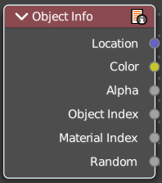
Object Info
The Object Info node gives information about the object instance.
Note that this node only works for material shading nodes; it does nothing for light and world shading nodes.

Outputs

Location
Location of the object in world space.

Color
Object color, same as Color in the Properties Editor > Object > Viewport Display.

Alpha
Alpha color for the Object Color, if existing.

Object Index
Object pass index, same as Pass Index in the Properties Editor > Object > Relations.

Material Index
Material pass index, same as Pass Index in the Properties Editor > Material > Settings.

Random
Random number unique to a single object instance.

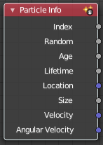
Particle Info
Cycles Only
This node gives access to the data of the particle that spawned the object instance.
Note that this node currently only supports parent particles. Info from child particles is not available.

Outputs

Index
Index number of the particle (from 0 to number of particles).

Random
A random per-particle value in the range from 0 to 1. It can for example be used in combination with a color ramp, to randomize the particle color.

Age
Age of the particle in frames.

Lifetime
Total lifespan of the particle in frames.

Location
Location of the particle.

Size
Size of the particle.

Velocity
Velocity of the particle.

Angular Velocity
Angular velocity of the particle.

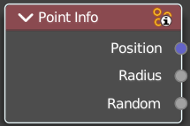
Point Info
Retreive info from a point cloud. Just cycles. Eevee is not yet supported.

Outputs

Position
The position of the point cloud.

Radius
The radius of the point cloud.

Random
A random point in the point cloud.

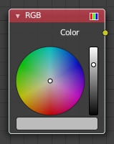
RGB
Set a color.

Properties
The RGB node uses the color picker widget.

Outputs

Color / RGBA
A single RGBA color value.

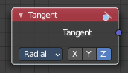
Tangent
The Tangent node generates a tangent direction for the Anisotropic BSDF.

Properties

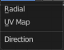
Direction Type
The tangent direction can be derived from a cylindrical projection around the X, Y, or Z axis (radial), or from a manually created UV Map for full control.

Outputs

Tangent
The tangent direction vector.

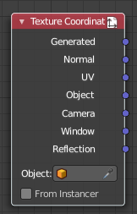
Texture Coordinate
Define some texture coordinate types. The types are pretty self explaining.

Properties

Object
Specific object to use for object space coordinates. This only affects the Object output.

From Instancer
Cycles Only!
If the object is generated by instancing from vertices or faces, use texture coordinates from instancer. This only affects the Generated and UV outputs.

Output

Generated
Uses automatically generated texture coordinates, calculated from the bounding box.

Normal
Uses the normals for the texture coordinates.

UV
Uses the UV mapping for the texture coordinates.

Object
Uses the Object for the texture coordinates.

Camera
Uses the position coordinate in camera space for texture coordinates.

Window
Uses the location of shading point on the screen.

Reflection
Uses the direction of the reflection vector as texture coordinates.

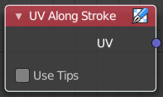
UV Along Stroke
Line Style Mode Only
The UV Along Stroke input node maps textures along the stroke length, making it possible to mimic pencil, paintbrush, and other art medium marks.
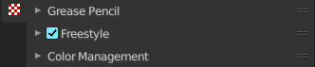
The pattern type can be set up in the properties editor in the Freestlye Line Style panel in the View Layer Properties tab. Don't forget to turn on Line Style in the Render Properties first. Or the Freestlye panels will not show.
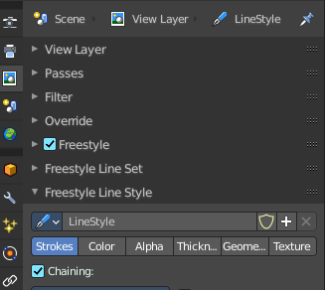
Note! These UV maps become available only during the Freestyle rendering process. This means that the UV Along Stroke node cannot be replaced by the conventional UV Map input node. Since it takes an existing UV map already defined as part of mesh data.

Properties

Use Tips
Allows to use lower quarters of a texture image for the head and tail tips of a stroke, while the upper half for the stroke body.

Outputs

UV
UV maps defined along strokes.

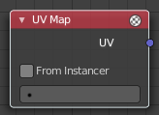
UV Map
The UV Map node is used to retrieve specific UV maps. This node can retrieve any UV map that belongs to the object with this material.

Properties

From Instancer Cycles Only
See the From Instancer option of the Texture Coordinate Node.

UV Map edit box
UV map to use.

Outputs

UV
UV mapping coordinates from the specified UV map.

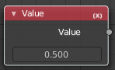
Value
The Value Node is a simple node to input numerical values to other nodes in the tree.

Properties

Default Value
Type in a single numerical value (floating point).

Outputs

Value
The value set in the options.

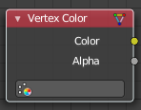
Vertex Color
The Vertex Color node provides vertex colors as well as their alpha value.

Properties

Vertex Color
The target vertex color. The listed vertex colors are those of the mesh of the active object.
If the active object has no mesh, a warning will be displayed. If the property is marked in red, it means the vertex color is not available in the mesh of the active object, but it may be available in other meshes of objects that share this material.

Outputs

Color
The vertex color.

Alpha
The alpha value.

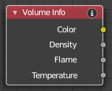
Volume Info
The Volume Info node provides information about Smoke Domains.

Outputs

Color
Smoke color.

Density
Smoke density.

Flame
Fire density.

Temperature
Temperature of the fire. Values in the range [0, 1] linearly maps to temperatures in the range [0, 1000] in Kelvin.

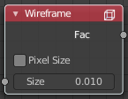
Wireframe
The Wireframe node is used to retrieve and render the wireframe of the object. This happens as the edges of the object appears to Cycles.
Meshes are triangulated before being processed by Cycles. So the topology will always appear triangulated when viewed with the Wire frame node.

Inputs

Size
The input value used for unconnected socked.

Properties

Pixel Size
When enabled, the size of edge lines is set in screen space.

Outputs

Factor
Black-and-white mask showing white lines representing edges according to the object’s topology.

